**DAILY ONLINE ACTIVITIES SUMMARY**

|  |  |  |  |  |  |  |  |  |
| --- | --- | --- | --- | --- | --- | --- | --- | --- |
| **Date:** | **17-06-2020** | | | | | **Name:** | **Kanaka BS** | |
| **Sem & Sec** | **6th & A** | | | | | **USN:** | **4al17cs039** | |
| **Online Test Summary** | | | | | | | | |
| **Subject** | | **Programming in C(Quiz)** | | | | | | |
| **Max. Marks** | | **15** | | **Score** | | | **12** | |
| **Pre-Placement Training Summary** | | | | | | | | |
| **Course** | Programming in C  Applications of python in DA and ML | | | | | | | |
| **Certificate Provider** | | | **Vivek Sharma**  **Dr. Mohideen**  **Badusha** | | **Duration** | | | **4hours** |
| **Coding Challenges** | | | | | | | | |
| **Problem Statement:** 3 Programs | | | | | | | | |
| **Status: Solved** | | | | | | | | |
| **Uploaded the report in Github** | | | | | **yes** | | | |
| **If yes Repository name** | | | | | **Online Coding Repository**  <https://github.com/kanakabs/Daily-Status/tree/master/17-06-20>  **Programming in C Repository**  <https://github.com/kanakabs/Programming-in-C>  **Workshop on Application of python**  <https://github.com/kanakabs/Online-Workshop-Applications-of-Python-programming> | | | |
| **Uploaded the report in slack** | | | | | **yes** | | | |

Programming in C Quiz

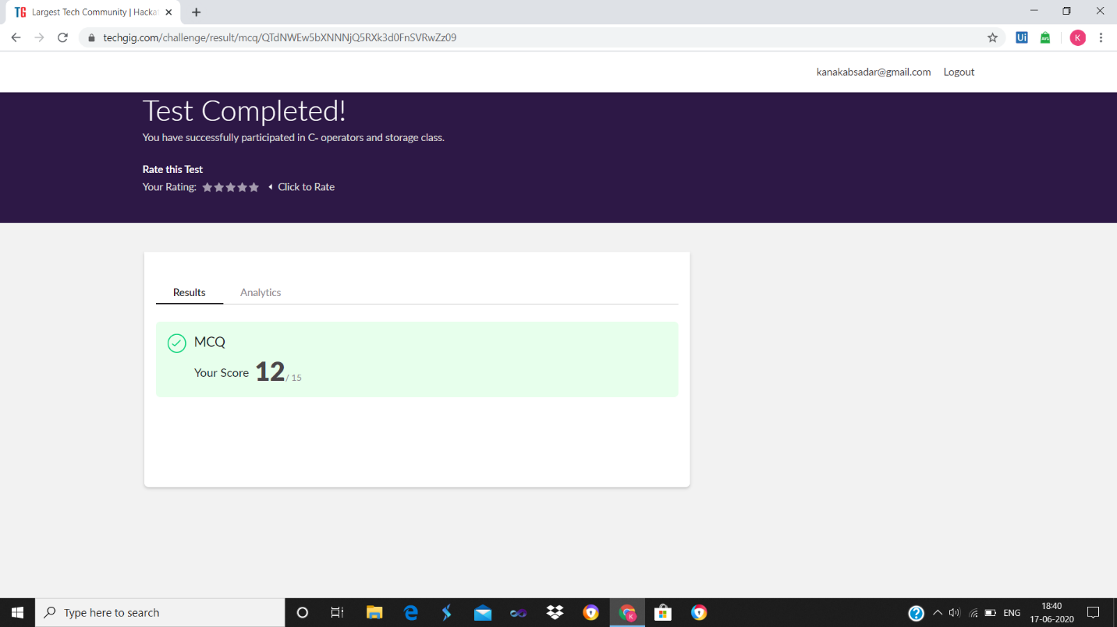

**SNAPSHOTS**

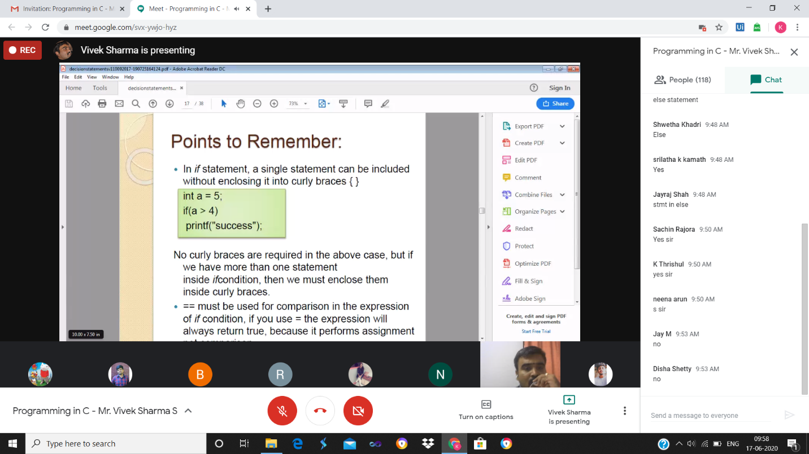

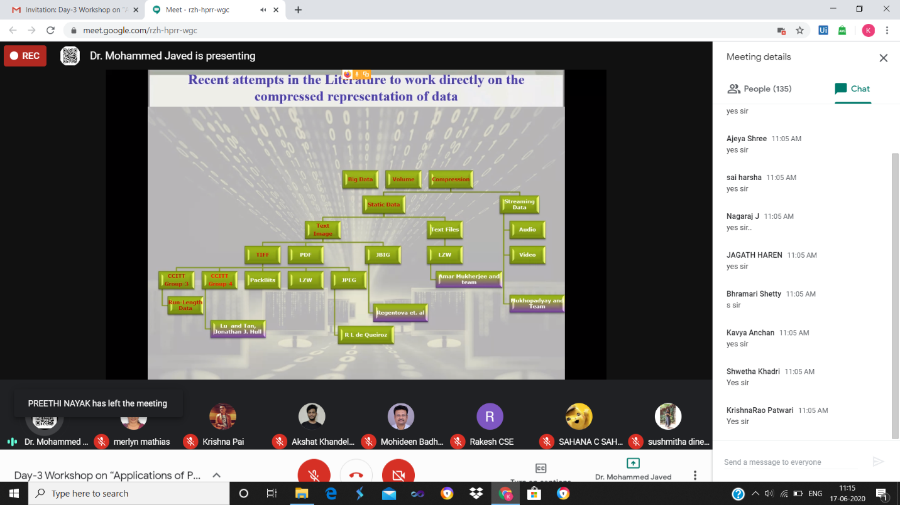

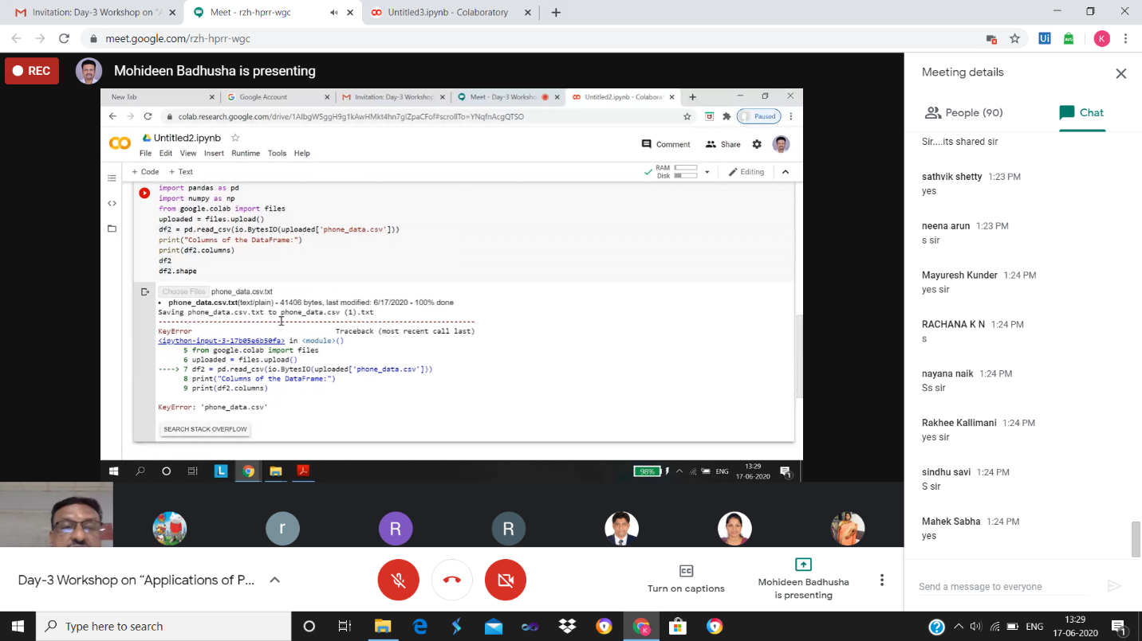

ONLINE CODING

